Lab Practical #05:

Study the concept of VLAN using packet tracer.

# Practical Assignment #05:

# Implement the different network structures in VLAN and VLAN trunking. Also check connectivity between them using ping command or PDU utility.

## VLANs configuration setup screenshot. (VLAN example given by lab faculty)

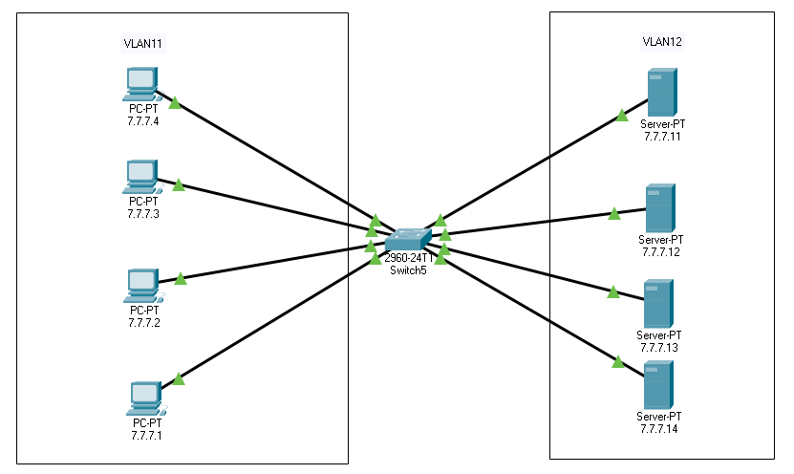

### VLAN Database

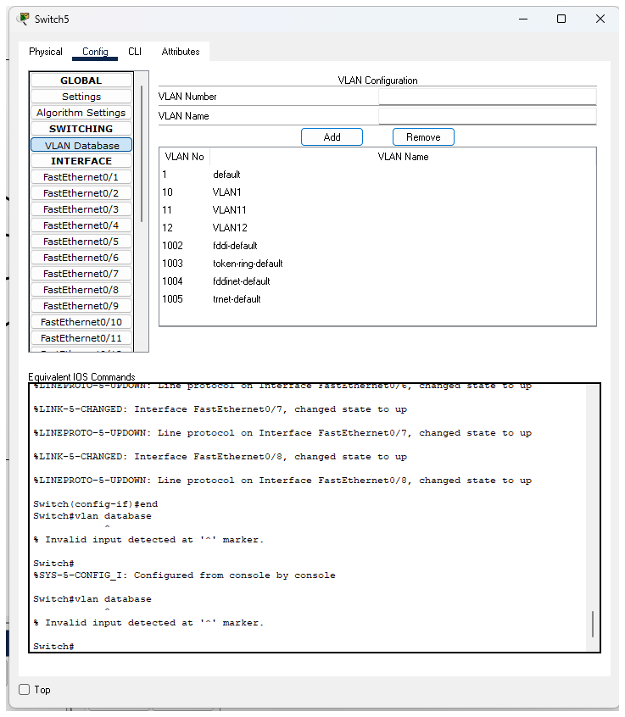

### Port

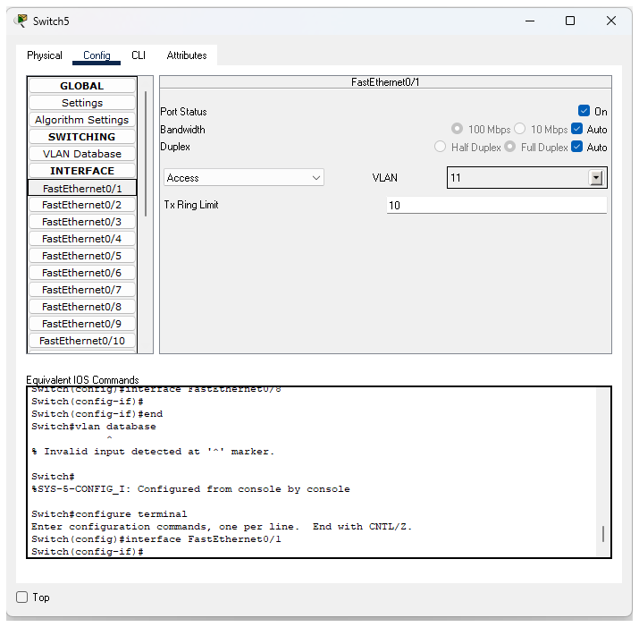

## 2. Steps to create VLANs in packet tracer.

**1. Open Packet Tracer and Add Devices**

* Drag and drop a **2960 Switch** from the network devices section.
* Add some **PCs** and **Servers** to the workspace.
* Connect them to the switch using **Copper Straight-Through cables**.

**2. Create VLANs on the Switch**

* 1. Click on the switch.
  2. Go to the **Config** tab.
  3. From the left panel, click on **VLAN Database**.
  4. In the VLAN Number field, type the VLAN ID (e.g., **11**) and give it a name (e.g., **VLAN11**).
  5. Click **Add**.
  6. Repeat the same process for VLAN 12 (name it **VLAN12**).
  7. Now you will see both VLANs listed in the VLAN table.

**3. Assign Ports to VLANs**

1. In the same **Config** tab, click on **FastEthernet0/1** (or whichever port a PC is connected to).
2. Change **Port Mode** to **Access**.
3. From the VLAN drop-down menu, select **VLAN11** for PCs.
4. Do the same for all other PC ports (assign them to VLAN11).
5. Next, select the ports where servers are connected (e.g., FastEthernet0/5, 0/6, etc.).
6. Set **Port Mode** to **Access** and assign them to **VLAN12**.

**4. Configure IP Addresses**

* Assign IP addresses to each PC and Server by clicking on the device → **Desktop tab** → **IP Configuration**.
* Example:
  + PCs in VLAN11: **7.7.7.1 – 7.7.7.4**
  + Servers in VLAN12: **7.7.7.11 – 7.7.7.14**

**5. Test Connectivity**

* Use the **ping tool** or **add a PDU** to check communication.
* Devices in the **same VLAN** will be able to communicate with each other.
* Devices in **different VLANs** will not communicate unless you configure a router or Layer 3 switch for inter-VLAN routing.

## 3. PDU screenshot between two VLANs.

### Successful

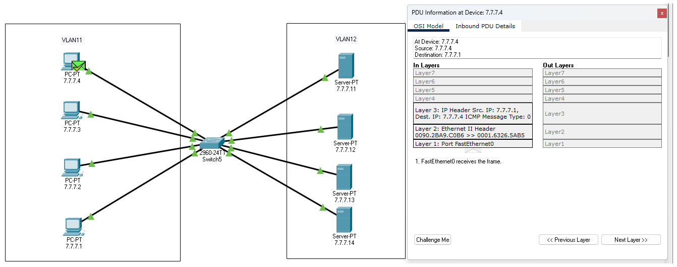

### Failed

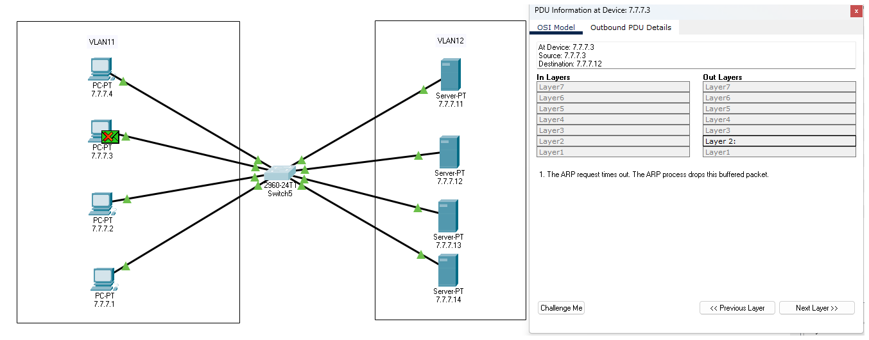

## 4. Mention IP address of each pc as label.

**For VLAN11 (PCs):**

1. PC1 → 7.7.7.1
2. PC2 → 7.7.7.2
3. PC3 → 7.7.7.3
4. PC4 → 7.7.7.4

**For VLAN12 (Servers):**

1. Server1 → 7.7.7.11
2. Server2 → 7.7.7.12
3. Server3 → 7.7.7.13
4. Server4 → 7.7.7.14